# Preface

‏‏SK presented his estimate of vaccine effects in CZ using his KCOR model, alongside several supporting analyses. All his analyses are deeply flawed in multiple ways, and show a net benefit, once the mistakes are corrected.

Document outline:

1. We first explain the main point of contention between the parties - selection bias vs vaccine induced death (VID).
2. We will then examine how many VIDs can be plausibly claimed.
3. Perform a full analysis of KCOR.
4. Correct its mistakes and present our model.
5. Refute SK’s supporting evidence.

# Selection Bias

The core disagreement between the parties is about attribution of patterns in the data to either selection bias or VID.

We first note that factors affecting selection bias between the vaccinated and unvaccinated change between demographies, interventions and time, and have not been fully understood in the literature. Contrary to our opponent, we do not claim to know what are the exact causes and prefer a more conservative approach of modeling them without claiming specific causes.

We further note that while the Healthy Vaccinee Effect (HVE) is seen in All Cause Mortality (ACM), we have not found any study claiming to find HVE in Covid deaths, nor has the opposition presented one.

There are actually good reasons to hypothesize HVE should not apply to Covid deaths. While it makes sense not to vaccinate a dying cancer patient, or a patient with advanced dementia who’s not dying soon but has very low quality of life, there is no reason not to vaccinate someone who is reasonably healthy but more susceptible to Covid, such as someone with damaged lungs who interacts with many people. Governments were universally pushing to vaccinate these individuals early and more frequently. There are of course many other biases, but overall, HVE for Covid deaths, if it even exists, should be lower than for ACM, not higher. We provide below evidence to support it is negligible.

**Note: all blue sections are SK quotes.**

## NPH

“I looked at pre-vaccine COVID mortality rates for full population cohorts of different ages relative to baseline mortality rates of the same FULL cohort (regardless of vaccination status).

I found that during COVID waves, ACM mortality did NOT scale linearly with baseline mortality, i.e., COVID was a non-proportional hazard (NPH).

The best estimate is to compute the mortality ratio between the cohorts and then multiply by an additional factor of ratio^.163. “

By definition, NPH should be applied only to Covid deaths. The correct formula is thus: non-Covid-mr * ratio + Covid-mr * ratio^1.163).

“α (the exponent) was estimated from four pre-vax age bands (1930–1960); bootstrapped 95 % CI = 0.106–0.223. Using any value within this range leaves ε≈1 (where ε = 1 means no benefit).. Details in KCOR_CMR_analysis:NPH estimate. There are other ways that get a higher value that I haven’t yet evaluated; this was my first try and it was sufficient to make my point.

For example, this means people with a 3X all cause mortality rate would be expected to produce a 3.6 higher COVID mortality, rather than a 3X higher COVID mortality. “

SK is retracting his previous claim of 0.5 NPH. Our calculations found 0.14 rather than 0.163, but we will accept 0.163 for simplicity. However, it should be clarified that this factor only applies to age. SK provides no evidence to support his claim that the same factor should apply to Covid mortality **within** the same age group, which is where he actually uses it. In any case, since we show that HVE does not apply to Covid deaths, the NPH factor is of no relevance (1 to any power remains 1).

## Static HVE

“When dealing with vaccinated vs. unvaccinated cohorts, there is a “static” healthy vaccinee effect that is typically around a 3X difference in mortality just after vaccination, consistent with other studies.

The unvaccinated cohort has **both** higher average mortality **and** frailty (these are orthogonal terms in the Gompertz mortality model).

Because the unvaccinated cohort is more heterogeneous and includes a greater share of frail individuals, it has a wider distribution of baseline hazards. If only the most frail die of COVID, that heterogeneity alone can make the vaccine appear to provide a large benefit, even when the biological effect is nil.

This is precisely why KCOR incorporates a slope normalization step which is highly unusual in epidemiological studies since those studies rarely deal properly with vaccinated / unvaccinated cohorts (invariably believing that Cox PH and other methods are appropriate which they can’t be because they don’t deal with the known complexities created by HVE).

In the Czech case, it is easy to validate a 3X baseline mortality difference created by the decision to vaccinate or not as shown in [KCOR_CMR_analysis](https://github.com/skirsch/KCOR/blob/main/analysis/Czech/KCOR_CMR_analysis.xlsx): 2021-24 3x static HVE tab which shows for fixed cohorts (born in 194x) the mortality rates of the cohorts (2,000 for Dose 2 vs. 6,000 for Dose 0 measured in low COVID period 2 weeks post enrollment to avoid dynamic HVE effects).”

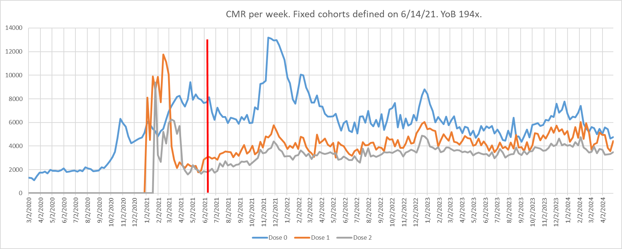

We note that SK asserts the entire field of epidemiology is incorrect and that only his unproven and never–peer-reviewed KCOR framework is valid. The implications extend far beyond COVID-19 and mRNA vaccines, as his claim would render studies on all vaccines and other pharmaceutical interventions inaccurate or invalid, contradicting decades of independent corroborating research. This is an extraordinary claim that requires extraordinary evidence—none of which is provided here or elsewhere.

# VID Plausibility

We took [CZ’s mortality data](https://ec.europa.eu/eurostat/databrowser/view/DEMO_R_MWK_TS__custom_2011619/bookmark/table?lang=en&bookmarkId=a222c8d9-99f7-4845-a3d1-7c63e35c2d21&c=1643734269886), and fitted a sine wave plus linear regression, through periods of low-Covid, in order to identify trends in non-Covid mortality.

Figure 1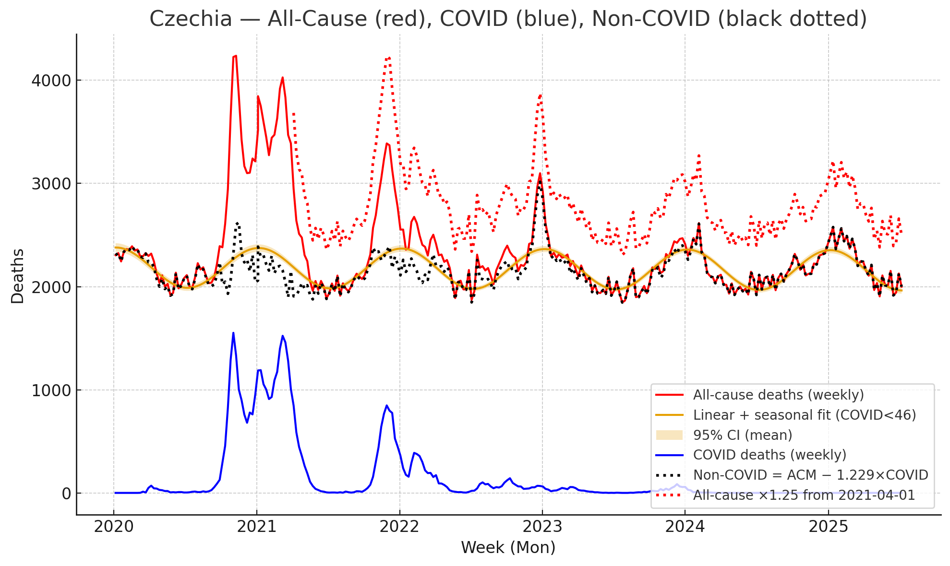

The parameters of the fit are:

* Intercept: 2184.725 [2153.410, 2216.040]
* Trend/week: −0.09664 [−0.25880, 0.06553]
* Amplitude: 194.243 [173.739, 214.746]
* Phase: 89.130° [82.881°, 95.378°] (i.e. practically 90°, which places the seasonality peak on January 1st).
* To get the summer trough values, we deduct the amplitude (alongside its CI) from the intercept (which is the mid-value), and get: 1990 [1953, 2028]

Note: To avoid arbitrary manual selection of low-Covid periods, as SK often does, we define these as periods where Covid is below the “noise” - the standard deviation of ACM, which, assuming a poisson process, is 2185=46.

We estimate the maximum increase in deaths that can be claimed, as follows:

* High CI for weekly trend is 0.06553
* The debate period is less than 2 years from first vaccinations.
* Maximum increase at 31-Dec-2022: 0.06553 * 105 weeks = 6.881
* Integrating over period: 6.881 * 105 / 2 = 361
* Thus, any claim above a total of 361 VID is in strong contradiction to reality.

A closer look at specific causes of death (CoD) corroborates the lack of change in mortality after vaccinations. We compared each CoD in 2021 relative to 2020 from [here](https://ourworldindata.org/grapher/annual-number-of-deaths-by-cause?country=~CZE&tableSearch=cz), finding the top 3 increases (excluding Covid):

Cancers: +100 (+0.325%)  
Dementia: +20 (+0.410%)  
Alcohol use disorders: +6 (+1.38%)

There is thus no single CoD that changed substantially.

The lack of VID is even easier to observe when looking at vaccinated zero-Covid countries, like Hong-Kong (below), which had [no excess deaths (ED) for 12 months after vaccinations](https://www.frontiersin.org/journals/public-health/articles/10.3389/fpubh.2023.1085451/full).

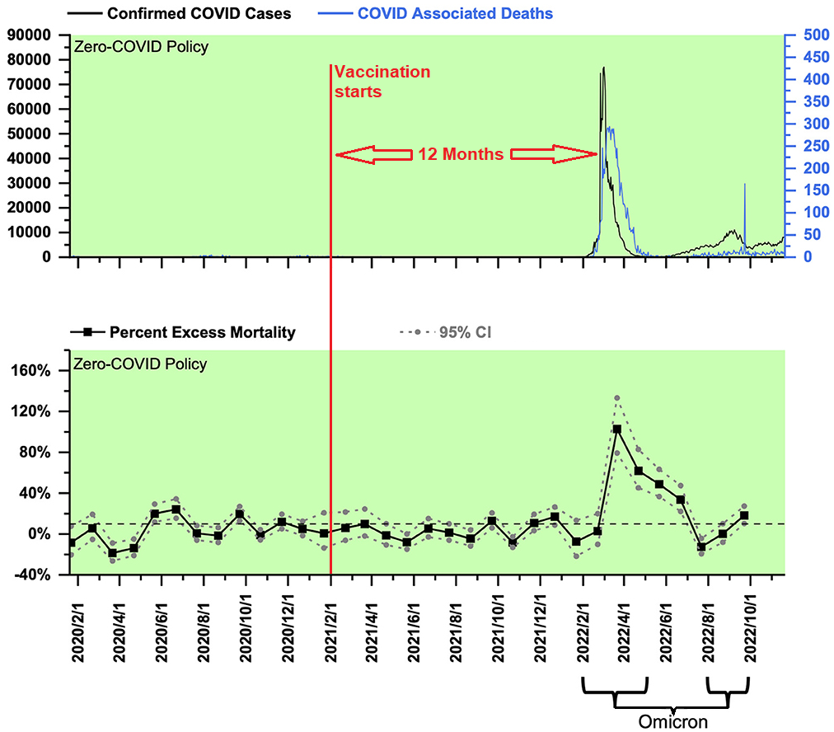

Figure 2

While nothing is certain in such complex systems, this evidence is enough to reach a highly confident conclusion that mRNA vaccines did not cause substantial VID in Czechia.

# KCOR Review

## Contradictions with Reality

Before delving into the many mistakes in KCOR, we first demonstrate KCOR cannot possibly be a valid model since it fails the most important test: Does it match observed reality?

KCOR is claiming excess ACM of 16-34% for dose 2 and ~50% for dose 3, by the end of 2022.

* Since ~75% of elderly Czechs are vaccinated (figure 15), and [40% of the population were boosted](https://ourworldindata.org/grapher/covid-vaccine-booster-doses-per-capita?country=~CZE), that should translate to over 25% total ED, or 500 extra weekly deaths (26,000 annually).
* In terms of standard deviations, using the 46 calculated above, this would be over 500 / 46 = 10.87 standard deviations (p=1.6E-27).
* The dotted red line in figure 1 shows what an increase of 500 weekly deaths would look like.

The contradiction can also be seen when breaking down by year of birth. KCOR provides wildly different results for each age: 1930-1939 at +6% and 1940-1949 at +29% - equivalent to a change of 23% between ages 83-92 and 73-82, but that is not seen in [mortality data](https://csu.gov.cz/produkty/number-of-deaths-weekly-and-monthly-time-series), where all age groups track proportionally before and after vaccinations:

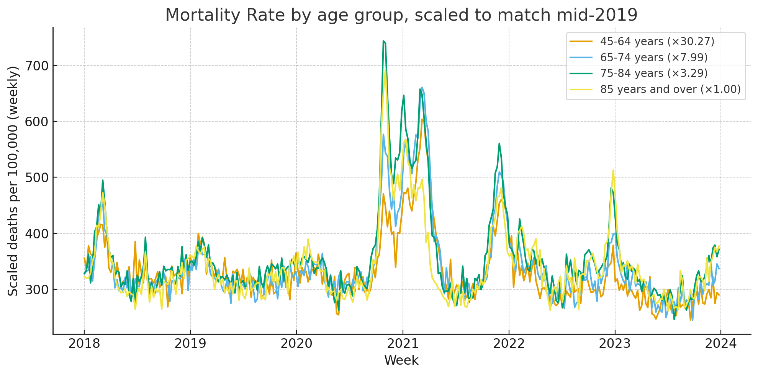

Figure 3

This contradiction with reality is exacerbated when incorporating specific claims of SK:

“It seems very old people (who were vaccinated in Feb) aren’t much affected by the COVID shots.”

* SK claims 80+ (shown in figure 12 to be half of deaths in Feb-2022) do not suffer VID, but that age group accounts for [46% of ACM](https://csu.gov.cz/rychle-informace/population-change-3-quarter-of-2015). So now these 25% excess deaths are nearly doubled for <80, and still somehow no statistically significant effect is seen.
* Note that this claim that 80+ don’t have VID **directly contradicts the main claim of the debate** that those born 1940-1949 have a net harm.
* SK claims VID mostly stops after one year, while we calculated the maximum over two years.

**“**[...] the top graph shows the third dose caused a huge mortality increase as compared to unvaccinated mortality. But **the dose 2 group who are nearly 1 year past their shot** date, **had mortality tracking the unvaccinated because the mortality increase caused by the shots are long gone**”.

* SK claims the vaccine benefit seen in KCOR is false (due to NPH). Thus, his claim of 25% ED is actually 35-40%, further contradicting observed reality.

Next we examine the actual errors and mistaken assumptions that led to these nonsensical results, along with the appropriate corrections.

## Technical Errors

1. SK does not filter by vaccine brand, while the debate question only relates to mRNA vaccines.
   * This is especially important in dose-1, since that includes fully vaccinated Janssen recipients.
2. In KCOR_CMR.py, SK deducts dose 1 twice from the ‘alive’ count (the denominator):
   * **Lines 685-971:** Identifies unvaccinated as those with no dose before enrollment, and puts them in trans_0
   * **Lines 709-715:** Turns it into cumulative
   * **Lines 741-745:** Deducts dose 1+ from dose-0, even though it never included them

These fixes change the dose-1 KCOR result substantially from 1.116 to 0.890, turning it into a net benefit (although not statistically significant). This invalidates SK’s claim of dose-dependency.

As a side note, we found that in some cases dose-dependency is reversed, with dose-1 appearing worse than dose-2, again indicating that KCOR is both inconsistent and does not match observed reality.

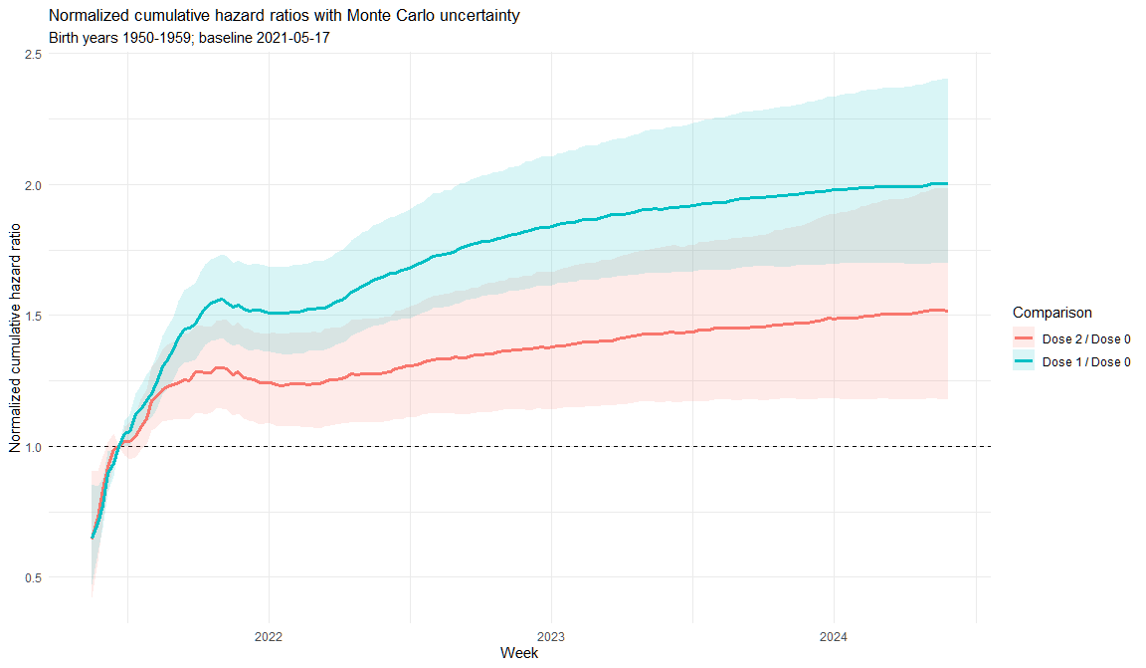

Figure 4

Dose- 2 is less affected, changing from 1.278 to 1.200.

### CI Calculation

The next mistake is in the calculation of the CI. SK’s calculation ignores the noise introduced by the slope normalization step, and by the normalization to 1 at 4 weeks after enrollment. This can be seen by the CI not converging to 1 at that date (red circle below), and not diverging over time.

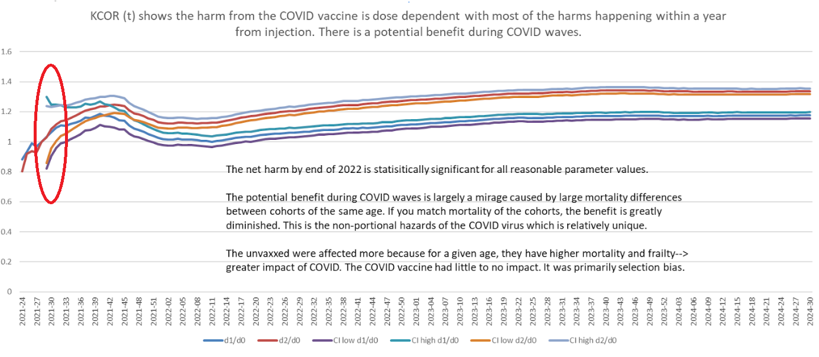

Since an analytical calculation of CI in such a complex model is easy to get wrong, we chose a monte carlo method.

This widens CI 4x from [1.254, 1.302] to [1.170 , 1.370].

Here is the KCOR plot after correcting these mistakes:

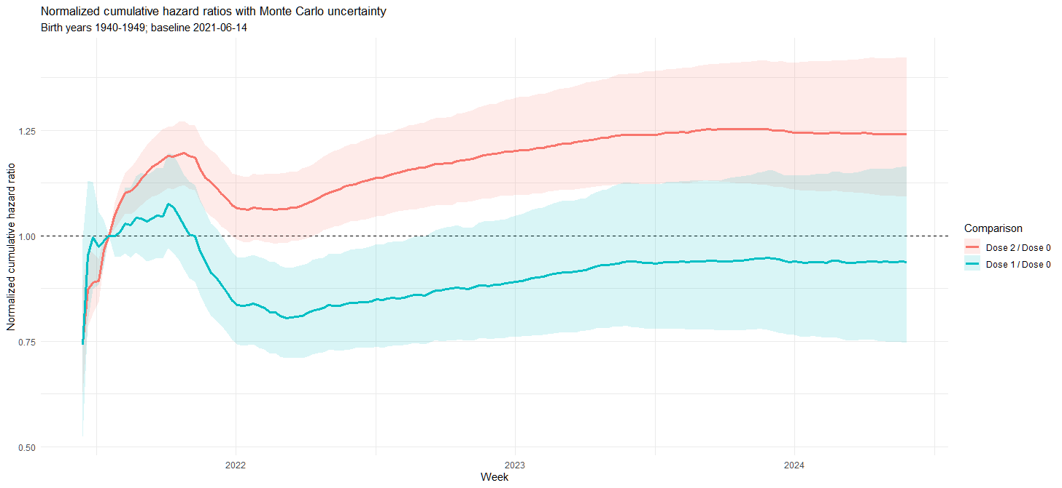

Figure 5

## Invalid Assumptions

The next mistake is in the “slope normalization” step.

In prior versions of KCOR, SK claimed mortality rate should be constant after the first few weeks, causing him to attribute any change to VID. SK now accepts that selection bias causes the cohorts to be heterogeneous in a way that causes a change in mortality beyond a few weeks. To control for that he adds a step of fitting an exponential curve to low-Covid periods, considering this the new baseline-mortality, and changes from it as VID.

In this process he makes several mistakes, but before going through them, it’s important to understand that once this assumption is accepted, there is no way to identify VID.

Changes in mortality over time are now attributed to a combination of two factors: VID, and changes in cohort composition. Mathematically, there is no way to separate them, unless assumptions are made. SK chooses to assume that the non-VID component is exponential, so anything above that is VID.

That assumption has multiple problems:

1. No evidence is provided for why it’s true.
2. The exponent is fit to the combined mortality rate, meaning the VID component (to the extent it exists) affects the fit. The claim that variation from that fit is VID is thus nonsensical - it just represents the failure of the function to capture both components.  
   For this to work, assumptions should be made about the behavior of both components, and a fit should be made to a function that represents both.  
   For example, this is what we’ve done above when fitting ACM to a sum of a sine wave and linear regression, thus separating seasonality from long-term mortality trends.
3. No verification is made that the assumption doesn’t violate reality. For example, this model often results in the adjusted mortality rate of the unvaccinated trending downwards. This trend is then incorporated into the final ratio, resulting in a higher VID estimate. However, this implies the unvaccinated are being healed from various diseases by not taking the vaccine - a nonsensical conclusion that invalidates its premises.

### Implementation Mistakes

In addition to the whole model being based on invalid assumptions, SK made several mistakes in implementing it:

* Mistake 1: Using an exponential curve without an asymptote.   
  This means that over time SK expects the mortality rate to approach 0 for negative s, or 100% for positive s (infinity before the transform to hazard). Both of which are poor representations of reality, as that is not how mortality behaves in the real world.

6. Use that slope s computed for each cohort to adjust each hazard value: adj_hr= raw_hr*exp(-st) where t=number of weeks from enrollment.”)

* Mistake 2: Fitting this curve to two points (each an average of 13 weeks chosen with no clear justification other than being low Covid) rather than fitting a curve that minimizes deviations from all relevant points, as customary in statistics.
* Mistake 3: Fitting a separate curve to each cohort separately, and calculating their ratio later. When doing the ratio first, correlated death factors such as flu seasons are neutralized, allowing for a more accurate fit.

### Week 5 Normalization

Another wrong assumption is made in the step of normalizing to the value after 4 weeks (actually, the code does it at week 5). In previous versions, this represented the assumption that the mortality rate is constant per cohort, after a few weeks of “dynamic HVE” - and therefore, any increase above it is VID. However, in this version where the slope normalization is supposed to neutralize the changes in each cohort, it is unclear what is the purpose of this step. It seems to represent an assumption of a super-exponential short-term HVE on top of the exponential long-term HVE. No justification is given for any of these assumptions.

Additionally, we note that usually the adverse events of an intervention start high and subside over time, while here the claim is reversed. A “typical” adverse reaction should be modeled with the long-term mortality rate representing the baseline, and early mortality above that being VID. KCOR instead treats a low short-term mortality rate as a signal of VID.

It can be safely assumed that if selection bias would have caused deaths to start high and then decline (e.g. preference to vaccinate those nearing death), then the opposition would claim this is an obvious death signal, showing how the vaccines are toxic, killing people immediately, and gradually declining to the background mortality rate as the toxin is cleared by the body. Indeed, when such a pattern is seen, SK makes this claim.

Together these mistakes result in the high net harm estimates (which we’ve already shown completely contradict ACM in Czechia). Different choices could have produced the opposite results, such as exaggerated net benefit.

## Sensitivity Analysis

To estimate KCOR’s sensitivity to SK’s seemingly arbitrary choice of parameters, we ran the 1940-1949 KCOR (after correcting the technical mistakes), using different values for the weeks skipped at the start of the data (we show here there is high uncertainty around this parameter):

|  |  |
| --- | --- |
| Change in skipped weeks | Result |
| -1 | 1.240835 |
| 0 | 1.200244 |
| +1 | 1.144441 |
| +2 | 1.11395 |

These are highly unstable results, strengthening our conclusion that KCOR’s results are statistical noise rather than a representation of reality.

# Our Methodology

While there are better options, for simplicity and word count, we will accept the core concepts of KCOR: Using fixed cohorts at 21-Jun-2021, born 1940-1949.

We start with the same data as KCOR - mortality rate per fixed cohort:

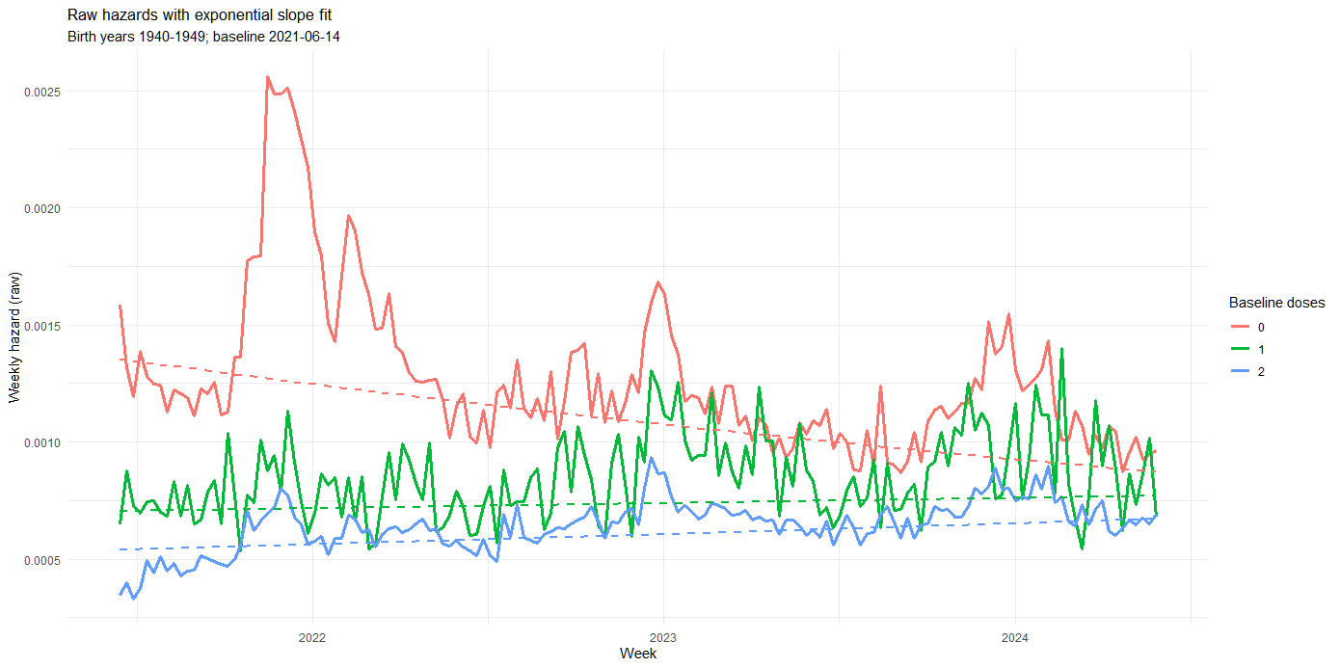

Figure 6

Trendlines are KCOR’s exponential fit (which come out near linear due to his mistake of not having an asymptote).

As explained above, without specific assumptions on how VID and selection bias behave, there is no way to separate the two from this dataset. Some assumptions can be claimed to be more reasonable: A spike in deaths immediately after vaccinations solely in the vaccinated, is more consistent with our experience with VIDs than with selection bias.

However, in our case we’ve already shown that VID is negligible, so we can shift our focus to estimating lives saved.

## Estimating Lives Saved

We agree with the opposition that estimating VE is not trivial, given the different composition of the cohorts. Our approach is thus to model the selection bias and then control for it.

This is done as follows:

1. As there are factors that affect mortality in both cohorts, instead of modeling each cohort separately, we first calculate their ratio (Figure 7). This is indeed less noisy, neutralizing the flu/seasonality peaks around Dec-22 and Dec-23 seen in figure 6.
   * This alone invalidates the claim of HVE applying to Covid (and thus NPH) - There is no reason why susceptibility to Covid should be very different than to influenza, and both cohorts show the same susceptibility to the latter. The only difference remaining to explain the stark difference during Covid waves is thus the vaccine.
2. We observe the ratio seems to follow an exponential decay to an asymptote, which is expected from a phenomenon that is strong following vaccination and then weakens.
3. We keep only data from low-Covid periods (using the same method as here).
4. We fit an exponential function, as in KCOR, except we add the missing asymptote parameter A:  
    A + B * exp ( -k t )  
   The result is the black line in figure 7, parameters: A=1.124406, B=1.260077, k=0.019620, half-life=35.328 weeks

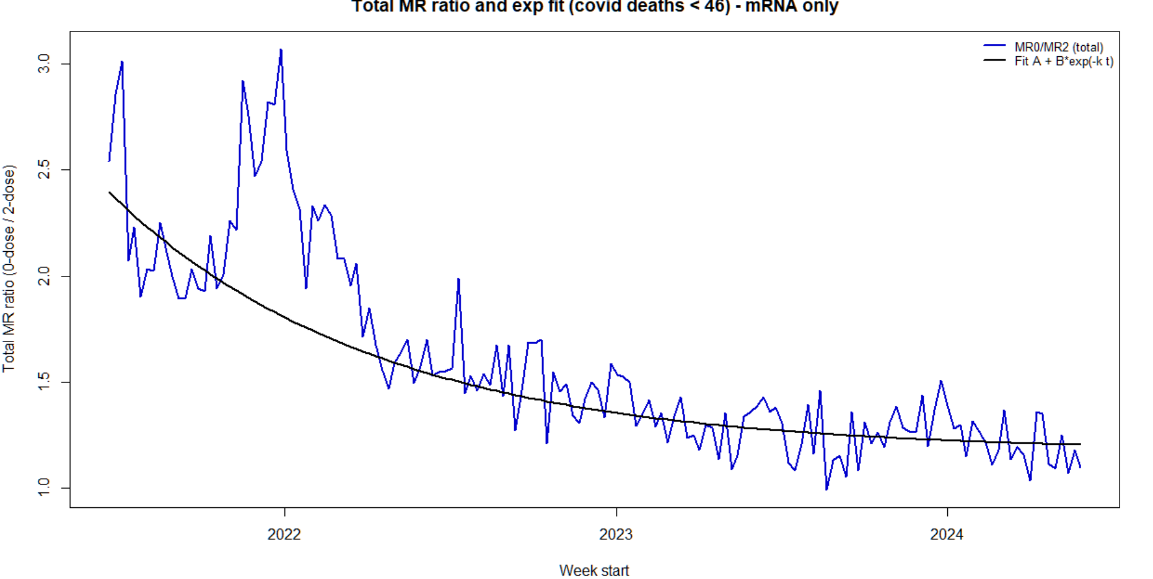

Figure 7

1. We separate Covid deaths (CD) from non-Covid ACM (NCACM), as follows:
   * Define CD’ as deaths that had an end of Covid hospitalization within 7 days prior.
   * Since CD’ can miss some Covid deaths, or include “deaths with Covid”, we estimate actual CD by finding a factor x that minimizes the pearson correlation between ( ΔACM - x * ΔCD’ ) and ΔCD’, weighted by ΔCD’, where Δ is the weekly change.
   * The result is x=1.229, i.e. actual CD = 1.229CD’
   * The dotted black line in figure 1 is ACM minus CD, appearing to show good separation of CD and NCACM.
2. To estimate lives saved, we compare CD between 2-doses and 0-dose recipients (as per the debate parameters), using two methods:
   * For both methods we calculate the counterfactual 2-doses deaths by applying to them the 0-dose Covid MR (i.e. how many would have died if they weren’t vaccinated).
   * **Method 1 - Equal Covid MR**
     + Assumption: Covid is not affected by selection bias. We provided multiple strong arguments for why this is the case.
     + Calculation:
       - Lives saved = counterfactual deaths - actual 2-doses deaths.
   * **Method 2 - NPH**
     + Assumption: Covid is over-affected by selection bias, to the 1.163 power, as claimed by SK’s. We’ve shown this contradicts reality, but still provide it for comparison.
     + Calculation:
       - Calculate the unbiased 2-doses Covid MR, by multiplying it by the exponential function fit to the MR ratio (figure 7).
       - Lives saved = counterfactual deaths - adjusted 2-doses deaths.
3. For the 1940-1949 age group, method 1 yields 5825 lives saved by the end of 2022 (95% CI: 5736-5909), and method 2 yields 4357 (95% CI: 4225-4484).
4. Below are the lives saved for all age groups.

|  |  |  |
| --- | --- | --- |
| Born | Lives saved assuming equal Covid MR | Lives saved assuming HVE+NPH |
| Before 1929 | 276 | 467 |
| 1930-1939 | 3500 | 3357 |
| 1940-1949 | 5825 | 4357 |
| 1950-1959 | 2090 | 1323 |
| 1960-1969 | 237 | 164 |
| After 1970 | -1 | 12 |
| **Total** | **11927** | **9680** |

1. We thus note that even under the unlikely assumption that HVE and NPH affect Covid deaths, we still get 9680 lives saved, With the low 95% CI far above even the hypothetical high 95% CI of 361 VID calculated above - **a clear net benefit**. Note that SK never provided an alternative calculation, using eyeball estimates of peak deaths instead.
2. This is an underestimate of lives saved, since:
   * Cohorts are fixed, and some in the unvaccinated cohort did get vaccinated later on, artificially reducing unvaccinated Covid deaths, and thereby the relative advantage of the vaccinated.
   * The distribution to 10-year age groups reduces most of the bias from elderly being prioritized for vaccinations, but still leaves some bias within each group (70 years old are more likely to be vaccinated than 61 years old, and are also more likely to die of Covid for the same vaccination status)
   * It misses the vaccine benefit prior to the baseline date.

In summary, we have shown KCOR is deeply flawed, most importantly making mathematically impossible assumptions about how VID can be extracted from mortality data. As a result, its products are unusable and contradict observed reality. Once correcting its mistakes and using valid assumptions, lives saved far exceed VID.

# Additional KCOR Issues

**KCOR method description**

KCOR is a method to assess net harm/benefit when you only have data on birth, death, and dates of vaccination. The output is KCOR(t) which for any point t summarizes the net harm/benefit of a cohort relative to another cohort, e.g., Dose 2 vs. Dose 0. KCOR(t) Values >1 mean cumulative net harm.

The graph below which shows Dose 2/Dose 0 and Dose 1/Dose 0 shows that **the vaccines cause a relative increase in mortality that is nearly linearly dose dependent**.

On the other hand, the benefit (the negative slope part) is the same shape and magnitude for Dose 1 vs. Dose 2 cohorts which means **the “benefit” is independent of dose. That would be consistent with a vaccine whose benefit comes from selection bias and not the drug itself.**

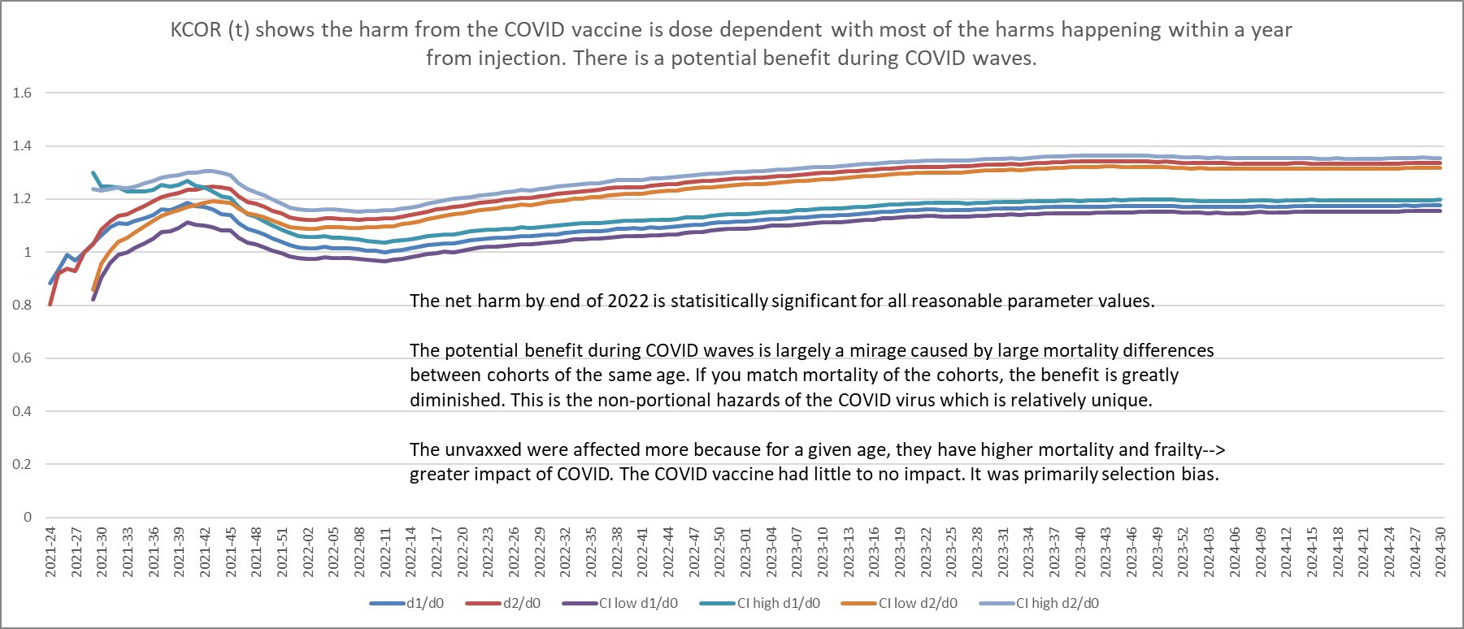

At the end of the day, we can clearly see that those who got 2 shots had a higher mortality increase than those who got one shot.

We have already shown that KCOR results are simply too random to be trusted for such conclusions and refuted the claim that its results show dose-dependency. We note that there is good evidence that nearly all the mortality benefit of mRNA vaccines is from the first dose.

Process:

1. Choose an enrollment date after most are vaccinated and right before a “no/low COVID period”

2. Enroll people in cohorts based on # of vaccine they received by the enrollment date

3. Track the alive/death count for each cohort each week

4. Convert to a hazard rate using -ln(1-mr)

5. Slope normalize the hazards for each cohort by fitting an exponential through the mean of two 12 week long “low COVID” windows chosen to be around 1 year apart   
 Exponential slope= ln(mean2)-ln(mean1)/(weeks between window center points)

Use that slope s computed for each cohort to adjust each hazard value: adj_hr= raw_hr*exp(-st) where t=number of weeks from enrollment.

6. Compute cumulative adjusted hazards per cohort by cumulating the hazards

7. Divide the cumulative cohorts of interest, e.g. Dose 2 CH/ Dose 0 CH

8. Normalize to the value of the ratio after 4 weeks.

9. Compute the CIs using

KCOR assumes proportionality **after** slope-neutralization; the independent NPH estimate (α) is not used in KCOR which makes the vaccine appear much safer than it really is.

We note that contrary to the debate’s contract and proper methodological practices, SK provides no process or explanation for specifically choosing the underlined figures. For example, the “12 week “low COVID” windows” used now, were 8 in SK’s V5 submission (which were not explained either, nor the switch between the two).

## Slope Normalization Failure

**KCOR_ns** column (the final column after the CIs) is without slope normalization and is more accurate for cohorts born on/after 1950 when there is less heterogeneity of the cohorts due to less depletion effects.

You can see a clear pattern of harm. The values are the KCOR(t) values at the end of 2022.

Dose combination: 2 vs 0 [2021_13] (this is an EARLY enrollment date)

--------------------------------------------------

YoB | KCOR [95% CI] | KCOR_ns

--------------------------------------------------

ASMR (direct) |  **1.3358 [1.313, 1.359] |** -

1920 | 1.1200 [1.083, 1.159] | 1.3883

1930 | 1.4946 [1.467, 1.523] | 1.6654

1940 | 1.4721 [1.431, 1.514] | 1.5763

1950 | 1.0088 [0.953, 1.068] | 1.1043

1960 | 1.6950 [1.534, 1.873] | 1.3283

1970 | 1.3068 [1.108, 1.542] | 1.1240

1980 | 0.6017 [0.458, 0.790] | 0.6932

1990 | 1.1353 [0.806, 1.600] | 1.1991

2000 | 3.1873 [1.024, 9.916] | 3.2341 (

The assertion that “cohorts born on/after 1950” exhibit “less heterogeneity … due to less depletion” is not supported by any empirical evidence and appears to also be a post hoc rationalization: this criterion was introduced only after KCOR produced a pattern that contradicts its own underlying assumptions. It is SK own claim that age is immaterial to KCOR:

“Most hazards are proportional. COVID is a rare exception. This is why, if you want to get an accurate assessment of VEdeath, you must compare v[accinated] v. u[nvaccinated] cohorts with the same mortality and frailty; **age is irrelevant**.”

In any case, SK claims that slope-normalization neutralizes heterogeneity, so less heterogeneous cohorts should simply have a mild slope, and little correction. There should not be any need to manually disable it.   
  
Moreover, SK explicitly treats consistency across age groups as a key validation check when it supports his interpretation:

**“Vaccine harm (elevated mortality on Dose 1 in early weeks).** The red box highlights a huge mortality differential between shot 1 and shot 2. It’s not noise. It’s consistent between age cohorts. **This is clear vaccine harm**. Nobody ever noticed this. AFAIK, I’m the first person in the world to point this out. “

In contrast, when KCOR yields highly inconsistent and implausible patterns by birth cohort, this same consistency criterion is not applied, and the discrepancies are instead dismissed by redefining which cohorts are considered “reliable.”

For a more in-depth analysis we plot KCOR’s outputs above, yielding the following:

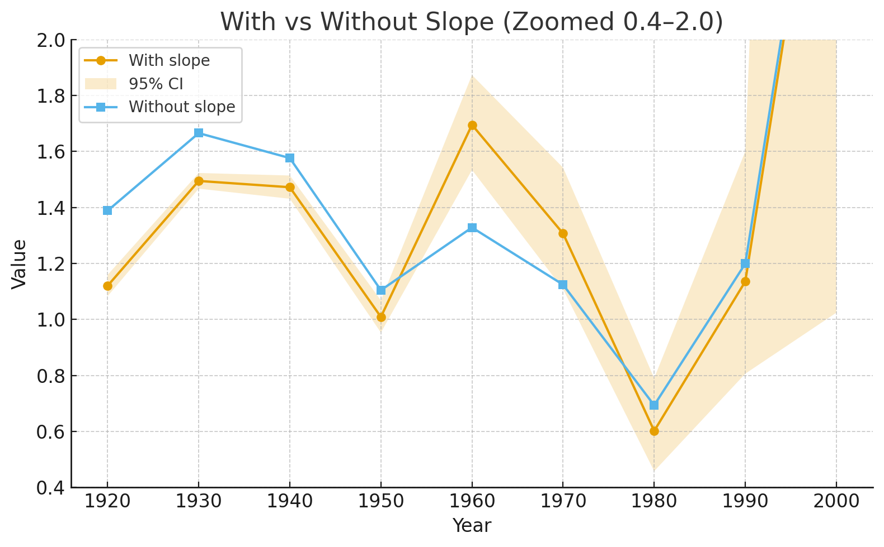

Figure 8

The magnitude and statistical significance of these differences further underscore the implausibility of the results. For example, the contrast between the 1940 and 1950 cohorts corresponds to an effect on the order of ~13 standard deviations (p ≈ 1.6 × 10⁻³⁸), which would imply a very strong real-world mechanism uniquely affecting individuals born 1940–1949 but not those born 1950–1959 or 1960–1969—an effect for which no plausible demographic, biological, or epidemiological explanation has been proposed.

## Dose 3

**“Here are the KCOR curves for the booster shots (3 v 0 and 2 v 0)**

This from KCOR_analysis: booster N v 0 ASMR.

This is really important because the top graph shows the third dose caused a huge mortality increase as compared to unvaccinated mortality. But the dose 2 group who are nearly 1 year past their shot date, had mortality tracking the unvaccinated because the mortality increase caused by the shots are long gone (**see note above about Enrollment date matters**).

As shown in figure 7, after a year, the exponential decline is milder, so the stability of dose 2 at this time does not require claiming a VID decline to explain it.

These two charts are very important because they also falsify the “it was HVE” claim. If HVE caused selection bias, the deaths from the dose 3 group would have to show up as excess in the dose 2 group and these two plots would be mirror images of each other. They are anything but. One is flat, the other has a rise.

The reason why dose 2 v 0 is flat is due to the observation point. The shots increase mortality levels in the first

This means the **rise in mortality is real and wasn’t created by selection bias**.”

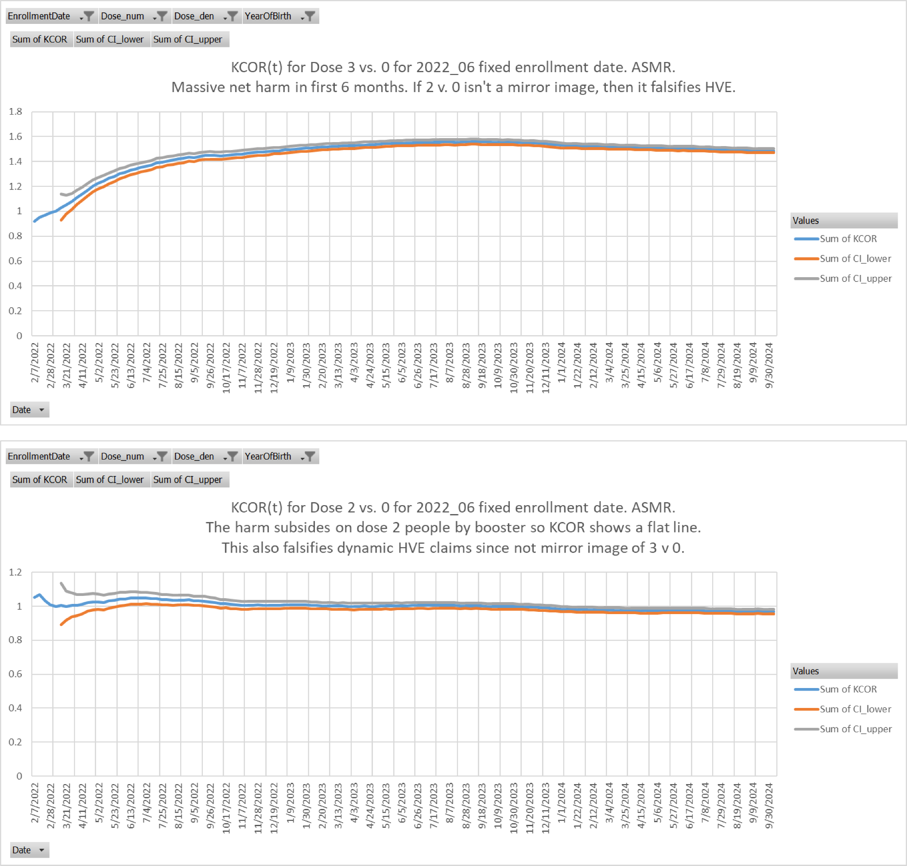

KCOR cannot be used to support these claims, both due to its flaws and due to it presenting cumulative data that can mask short-term trends. To claim that dose 2 does not present an increase in mortality rate due to HVE, detailed mortality rate charts should be provided.

## Medicare’s HVE

“The **event time-series data** shows HVE<14 days and **clear vaccine harm (two different ways)**

Event-time plots (US Medicare daily; Czech weekly) where the x-axis is time since shot was given show dynamic HVE is exhausted after 14 days, just like it is for every vaccine in every country.

This is why KCOR skips 2 weeks post-enrollment to account for this effect.

Below is US Medicare. You can actually count the 14 dots. “

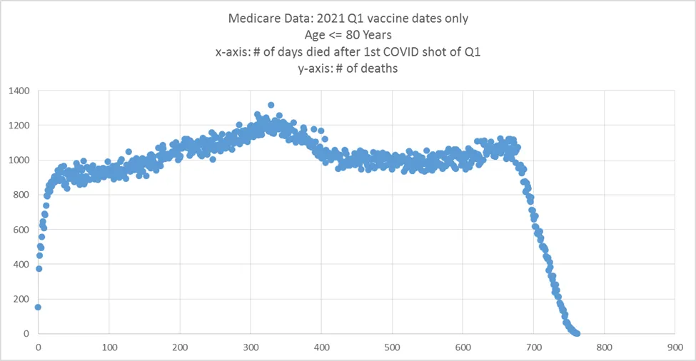

The claim that dynamic HVE is 14 days long for all vaccines is not corroborated by any evidence and is refuted by studies (e.g., This [study](https://pmc.ncbi.nlm.nih.gov/articles/PMC2728831/) found mortality increases for over 8 weeks after vaccination; see their figure 4). In fact, even in the graph above, we counted 24 dots to the bend and 36 until the peak.

HVE is affected by multiple factors, and as such, varies wildly between populations and times. A wide-spanning claim of 14 days HVE cannot be made from a specific chart from Medicare patients <80 years in Q1 2021.

More specifically, we’ve shown in figure 7 that selection bias (whether or not it’s HVE) for the group specifically selected as the focus of the debate follows an exponential decline with a half-life of 35 weeks.

## Dose-1’s “Toxicity Spike”

“We see the same thing in the Czech data, but with the Czech data, it’s weekly resolution.

The graph below (from KCOR_ts_analysis: dose 1 and 2 on the same plot is very revealing.

This is a graph of adjusted h(t) where we applied the standard 8.5%/yr mortality adjustment so that a flat mortality would be a perfectly horizontal line. This is all ages, all vaccination months, but limited to Dose 2 and shows adjusted h(t) relative to the timing of the Dose 2 shot.

This one graph shows 3 different things:

1. HVE lasted 14 days. Mortality stops increasing at week 3 (week 0 is shot week).

2. **Vaccine harm (elevated mortality on Dose 1 in early weeks).** The red box highlights a huge mortality differential between shot 1 and shot 2. It’s not noise. It’s consistent between age cohorts. **This is clear vaccine harm**. Nobody ever noticed this. AFAIK, I’m the first person in the world to point this out.

3. **Vaccine harm (elevated baseline mortality)**. When HVE is over in 2 weeks, you are left with baseline mortality of the cohort under study. Here you can see mortality rises from that point, stays elevated, then falls later. **If it wasn’t the vaccine what caused an elevated BASELINE mortality rate?”**

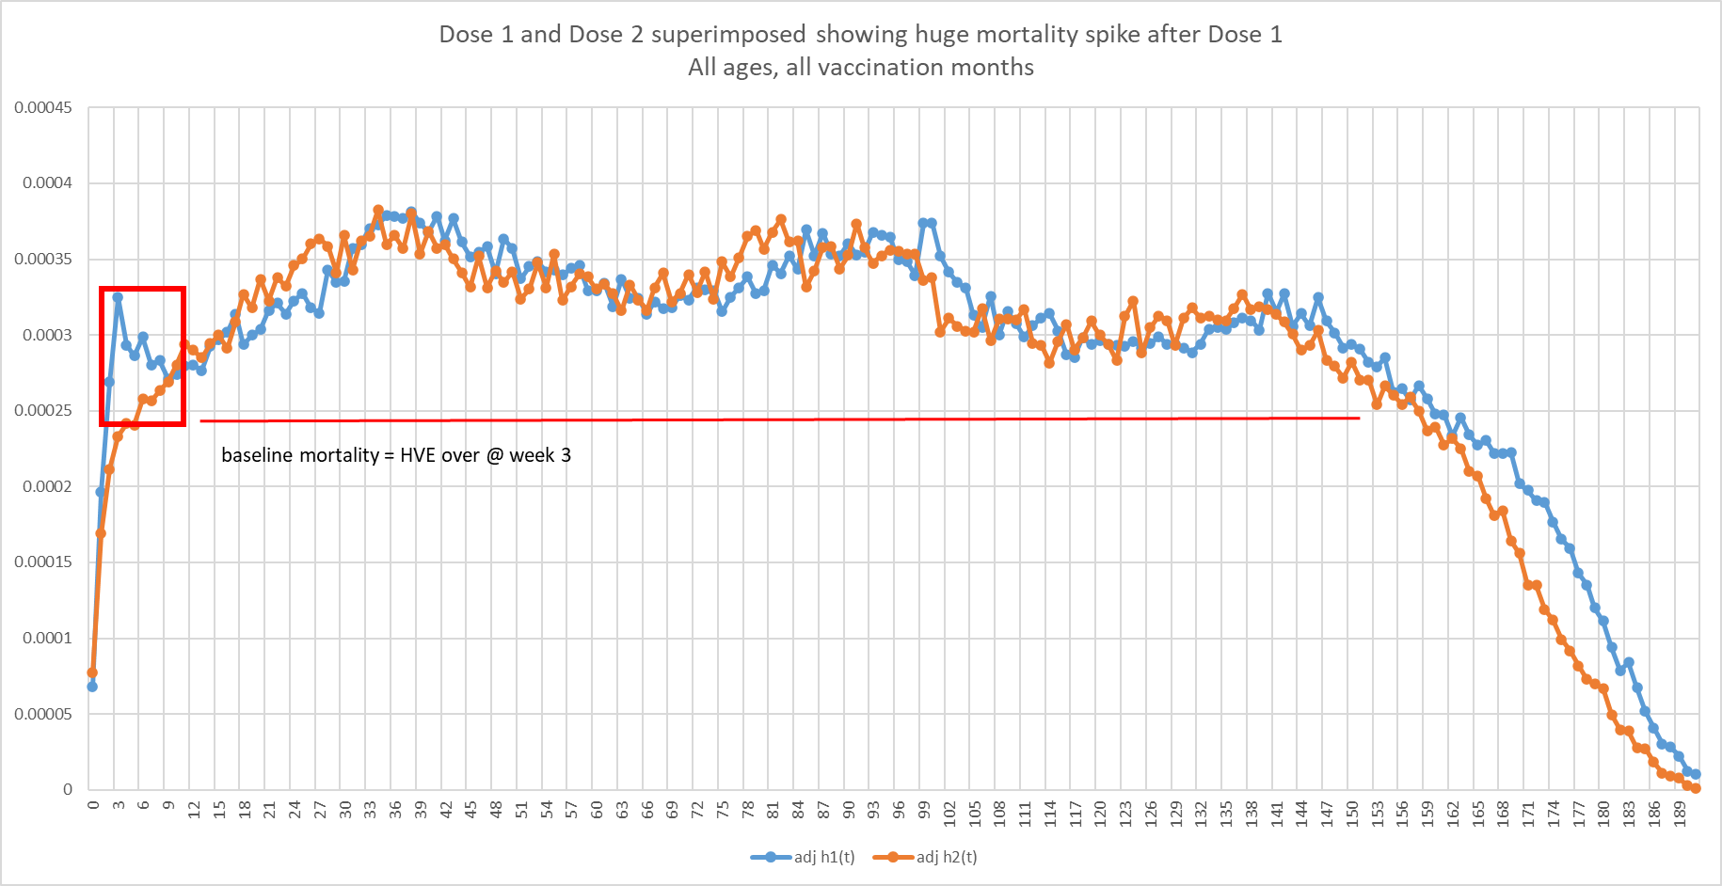

First, the increase continues for roughly 6 months (see below) and does not stop after 3 weeks. Secondly, SK is making a mistake of calculating MR with the wrong denominator: persons instead of person-weeks, causing the abnormal decline at the end of the period. Here is the chart corrected accordingly:

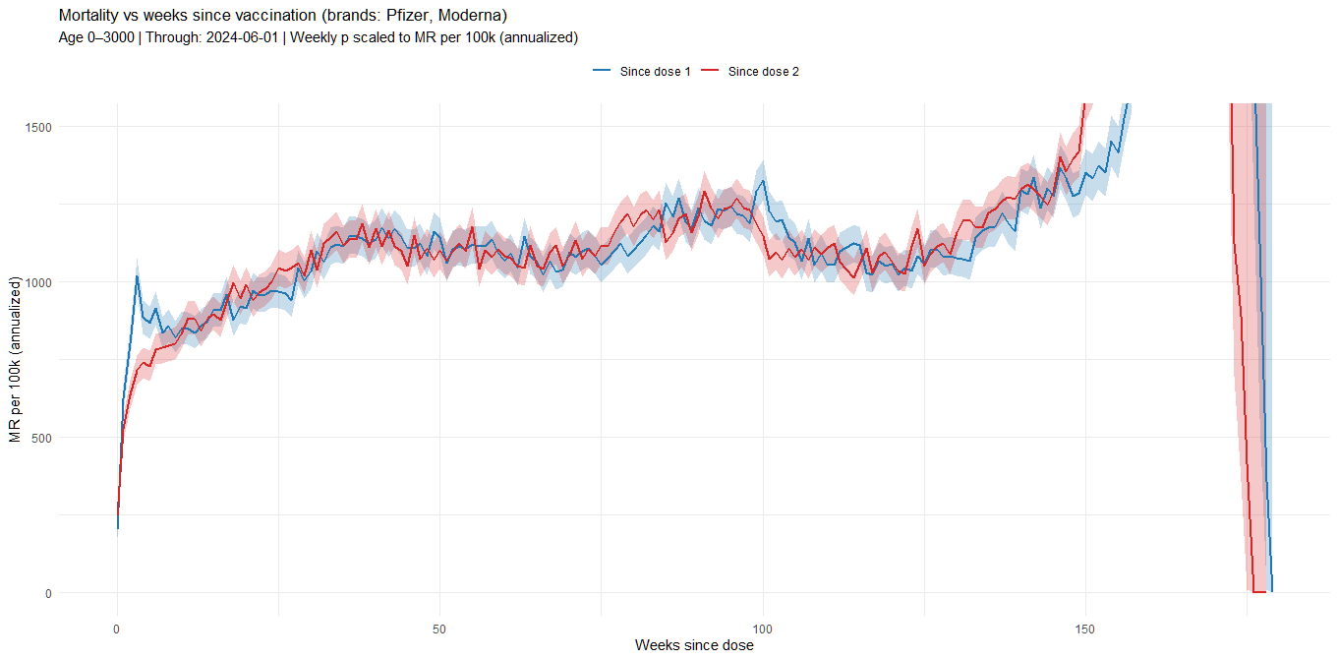

Figure 9

The increase at the end (which is anyway outside the debate’s period) is likely because long-term data exists only for early vaccinations, who are older, and thus have higher mortality rates.

Note this also contradicts SK’s claim that VIDs are “long gone” after one year as “they” remain elevated >3 years relative to SK’s incorrect baseline.

Next, once separating to Covid and non-Covid deaths, the source of the dose 1 early peak becomes obvious:

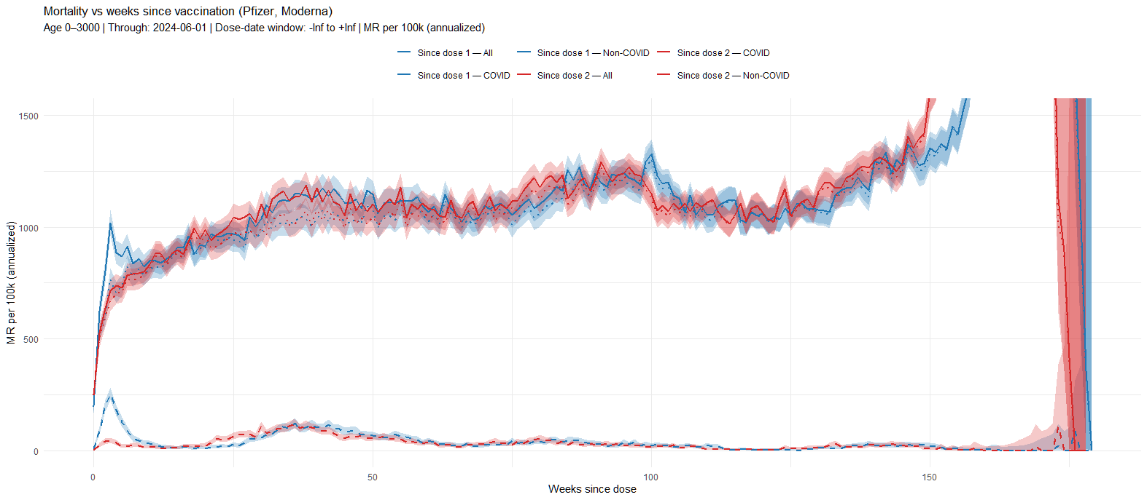

Figure 10

The peak is fully attributable to Covid deaths among dose 1 recipients. Once deducting those (dotted lines), there is no significant difference between the two.

The mRNA vaccine takes a few weeks to become effective, and dose 2 was given at a mean delay of 35 days (according to the dataset), so dose 2 recipients already enjoyed strong protection, and thus don’t have this early Covid spike.

Besides refuting SK’s new claim of dose 1 toxicity, it also refutes his main claim of no vaccine efficacy (attributing all differences to selection bias).

We can do a quick approximation of vaccine effectiveness by dividing the Covid mortality rates of the two groups over the first 3 weeks (when dose 1 recipients still don’t have protection, and are yet to receive dose 2). This produces a VE of 70.6%, 79.8% and 82.7%.

This method has many biases, but their effect should not be substantial:

1. Selection bias seems minimal between dose 1 and dose 2 recipients, as their non-Covid mortality rate is near-identical for years.
2. Since February saw an [increase](https://www.worldometers.info/coronavirus/country/czech-republic) of deaths throughout the month, and the share of dose-2 increases over time (initially there is only dose 1), there is a bias that increases Covid deaths among dose 2, so VE is underestimated.

## Dose-2, Feb-2021

“Many claim that HVE was extended in Czechia and the rise is just HVE. I falsified this in my Booster 3 v 0 compared to 2 v 0 plots above (they were not mirror images).

Here’s another plot from the same time series spreadsheet showing those vaccinated in Feb with Dose 2 had a perfectly flat mortality starting on week 3, when HVE ended, just as I claimed. It seems very old people (who were vaccinated in Feb) aren’t much affected by the COVID shots as you can see. Note their high h(t) values showing this really was the most elderly.”

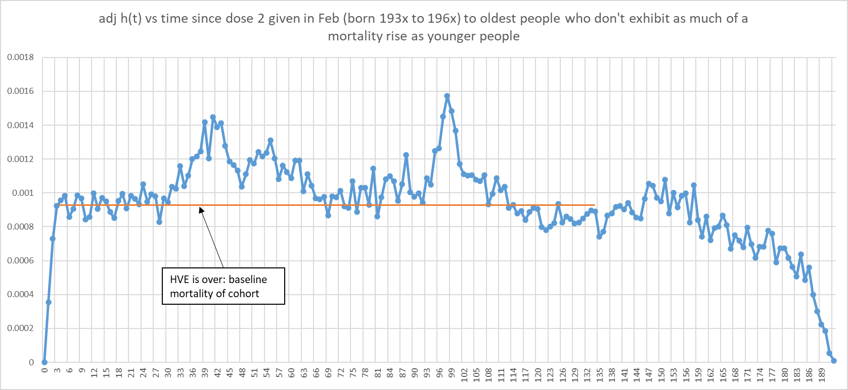

The plot above shows no increase above baseline, except for Covid deaths, indicating no VID (per SK).

We generated the same plot (below) just one month later (March) and it shows dose 2 rising substantially above the 3-week baseline, which per SK, indicates very high VID.

Incidentally, the artifact of dose 1 peaking early is absent because there is no Covid then.

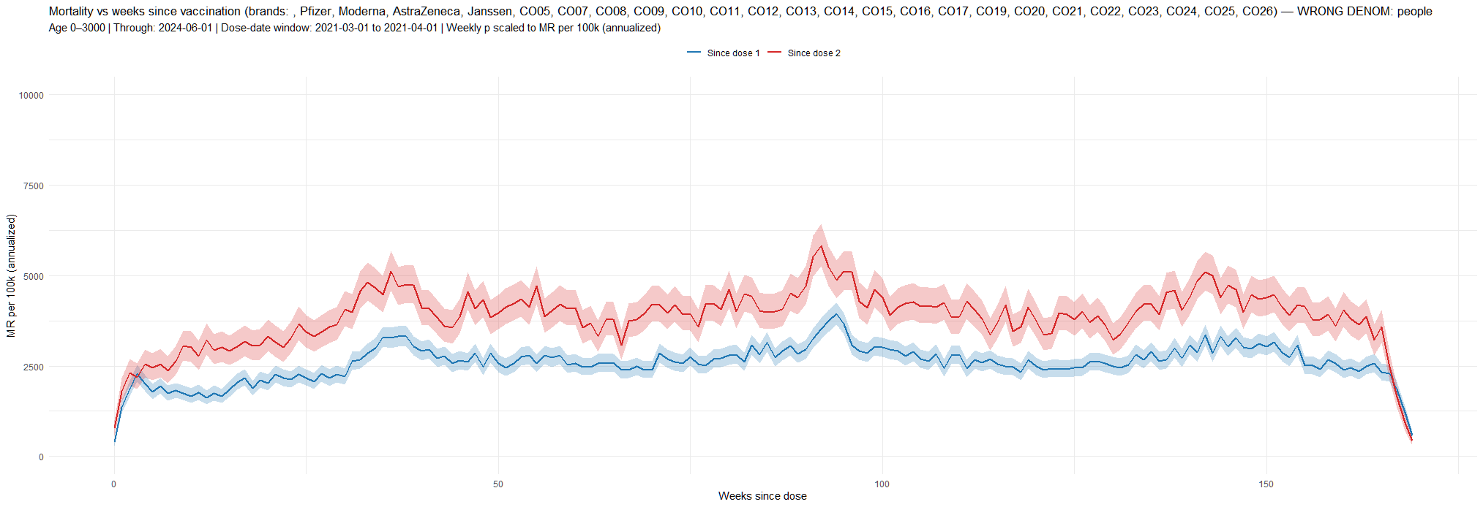

Figure 11

SK’s explanation that this is due to very old people not suffering VID does not match reality, since:

1. Around 35% of February vaccinations are below 60.
2. There are little differences in age distribution between February and March.

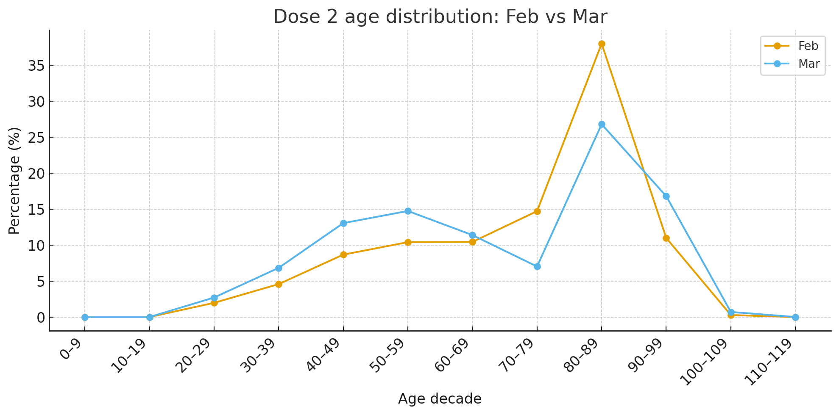

Figure 12

This slight change in age distribution is supposed to account for the vaccines changing from 100% safe to highly lethal. Since all age groups are represented in both months, and VID can not be negative, it is mathematically impossible for that to happen.

This is another contradiction of SK’s models with reality, supporting our hypothesis that VID are negligible, and the supposed patterns in mortality rate are thus selection bias.

## Peaks-based Calculations

**“The COVID vax “benefit” was caused by the static HVE selection bias + NPH**

Let’s continue with the same spreadsheet tab as we used in the previous section.

It shows that COVID mortality rose 2X from the non-COVID baseline (measured at enrollment) for the vaccinated (from 2000 to 4000) and by 2.15X (from 6,000 to 12,941) for the unvaccinated measured from the same baseline mortality time point.

While this may seem to be a 7.5% benefit for the vaccinated, this is not the case once we factor in the NPH effect.

Given r=3 and α≈0.163, if the vaccinated rose 2.0×, the **unvaccinated** are expected to rise 2.0×30.163≈≈2.39×  
  
But the unvaccinated increase during COVID was only 2.15 which is < the expected 2.39X.

That means **there was no mortality protection at all for the vaccinated**.

The vaccine all-cause mortality “benefit” during the Omicron wave was a statistical mirage created by selection bias (the static HVE effect) and non-proportional hazards.

Bottom line: the data shows that the COVID vaccine didn’t save any lives because the ACM ratios of the cohorts during the most important large COVID wave were proportional to the baseline hazards of the cohorts (modulo the NPH factor).

There was no cherry picking or hunting for this example. I had pre-specified the 1940 cohort well and enrollment date before I did this analysis.

It only takes one counter example like this to falsify the 10X mortality benefit claim. The data wasn’t even close to a benefit. It simply doesn’t work for the 1940 cohort. We’re done. [Full details here](https://chatgpt.com/share/6906b168-9fc8-8009-b374-a7501cbe4f76). “

We first note a recurring error in SK’s analysis, expecting a 10x benefit at all times. The vaccine’s 90% VE is relative to naive populations only. A baseline from Oct-2021 would be a diluted **Hybrid VE**, relative to the substantial natural immunity gained by the unvaccinated by then. This alone renders the entire “falsification” void.

Furthermore, measuring ED by comparing peaks and troughs is of course far from accurate. While SK claims “no cherry picking for this example”, excluding the full data and using only peaks and troughs is exactly a form of data selection tailored to fit the hypothesis (the full data is available, removing the need for such roundabout approximations). However, even under this method we can show the vaccines saved lives:

First, the NPH factor applies, by definition, only to Covid deaths. The correct calculation is thus: 6000 + 2000 * 31.163 = 13177, which is 2.196x increase, not 2.39x.

Another mistake is eyeballing a 2000 baseline, when it is 2611 when Covid starts (early Oct-2021) and 2893 when it ends (mid May-2022). Note SK recognizes this increase (wrongly attributing it to VID), but simply ignores it in this context. This changes the calculation to: 6000 + 1389 * (6000 / 2611) 1.163 = 9655, which is 1.609x.

Therefore, according to SK, the vaccine saved lives, with a peak CMR reduction in this group of 12941-9655=3286.

## CMR matching

**“We can use a completely different method to get the same NPH result**

We showed above that COVID mortality scaled super-linearly with your baseline mortality. The unvaccinated had higher COVID mortality simply because they had much higher BASELINE mortality.

So the COVID mortality benefit for a given age was simply due to the higher mortality/frailty of the unvaccinated cohort.

But there is an independent way we can demonstrate this effect more directly than mathematically.

Suppose we constructed two cohorts, one vaxxed, the other unvaxxed, but they had the same mortality and frailty because we used different age mixes or DCCI constraints to equalize the cohorts.

What happens is their vaccination status is immaterial with respect to their mortality during COVID vs. non-COVID.

In this section, we’ll show the same effect, but in the opposite way. We’ll show cohorts with the same mortality and frailty had the **same mortality increase during COVID irrespective of their vaccination status**.

**If you observe mortality-matched cohorts as we do in the chart below, the ACM mortality differential between cohorts during high COVID completely disappears!**

Most hazards are proportional. COVID is a rare exception. This is why, if you want to get an accurate assessment of VEdeath, **you must compare v v. u cohorts with the same mortality and frailty; age is irrelevant.**

To compare two cohorts, using time-varying ASMR cohorts is precisely the wrong approach. For COVID vaccine studies, to do a fair comparison, you must use FIXED cohorts, match mortality and frailty of the cohorts, and ignore age entirely.

It is easy to show that if we match mortality and frailty during non-COVID, **the ACM rise tracks precisely *during* COVID** regardless of vaccination status. This is extremely unlikely if the vaccines provide a 10x benefit. Source: KCOR_CMR_analysis: 2021-24 CMR matched DCCI>0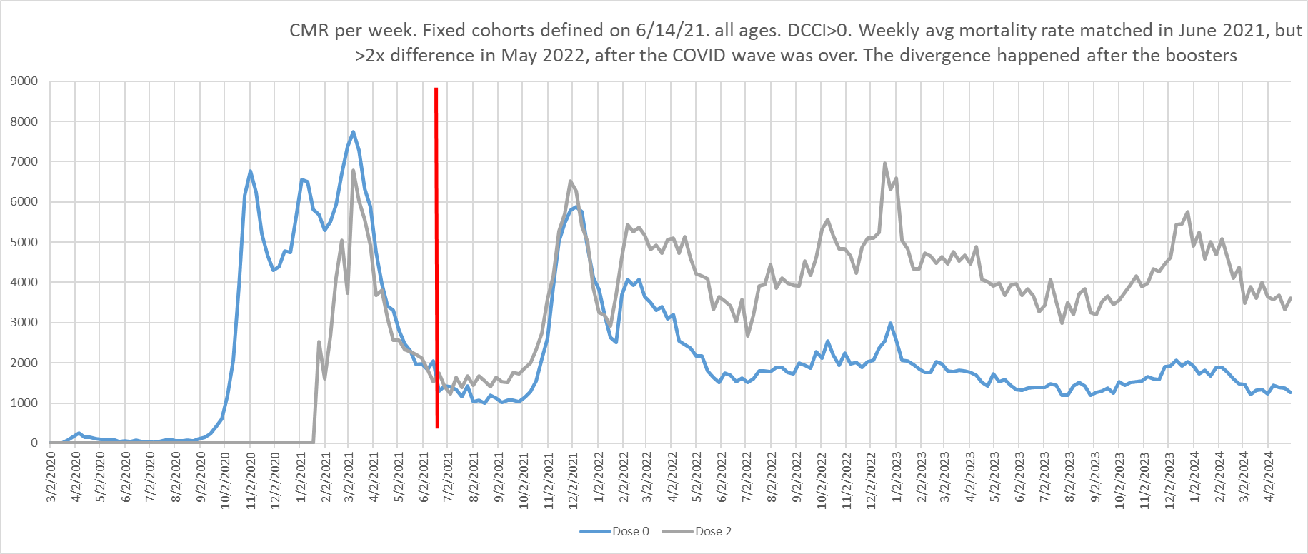

Here’s a second example of CMR matched cohorts showing they matched during COVID and non-COVID periods (from the CMR matched tab of the same spreadsheet):

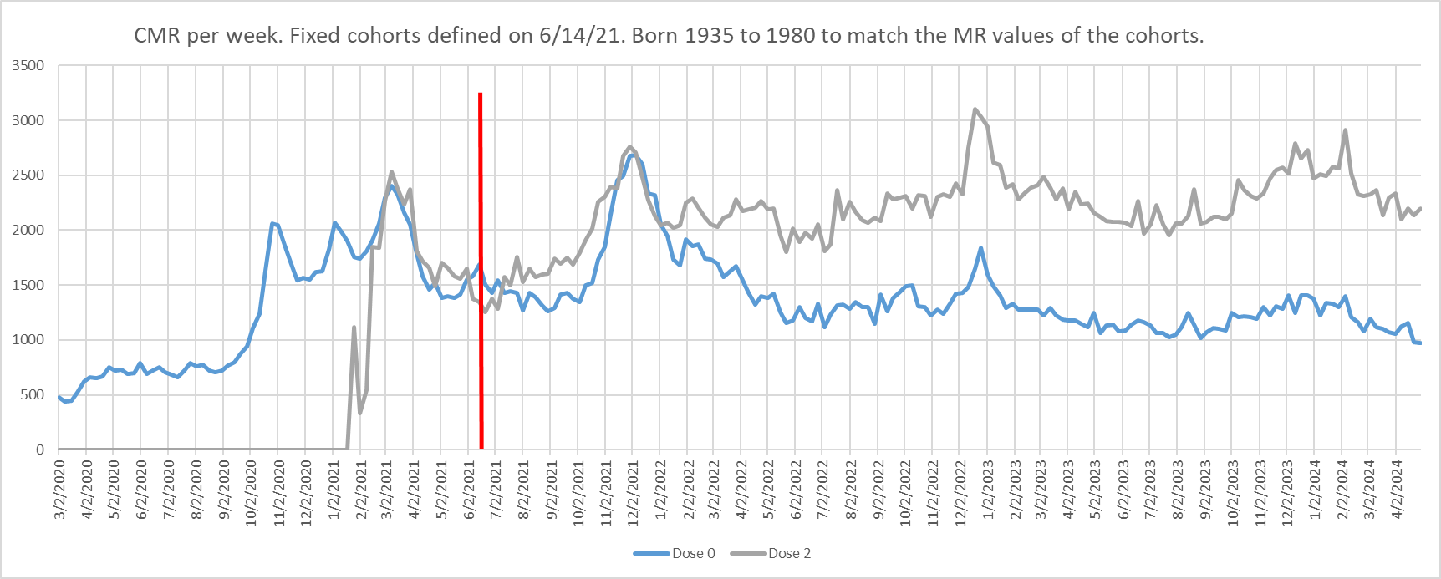

As you can see, **cohorts with the same baseline mortality and frailty had the same ACM increases during COVID waves REGARDLESS of vaccination status!   
  
In other words, it wasn’t the vaccine causing their immunity to COVID; it was their underlying health status.**

The primary error in this analysis is the assumption that the cohorts were adequately matched. They contain a wide range of ages, and are subject to high HVE in early weeks.

The supposed coordinated rise in ACM during Covid includes a concurrent decline in HVE, and those should be modeled and separated. The claim that the higher mortality after Covid is due to VID relies exclusively on the assumption that there is no such HVE decline, while figure 7 shows a long gradual decline.

This claim also contradicts SK’s own assertion that VIDs are “long gone” within one year. If the matching methodology were valid and successfully eliminated HVE, VIDs should diminish within six months and disappear entirely by twelve months. By his own admission, any MR difference persisting for two years cannot be attributed to VIDs. Consequently, the analysis is internally inconsistent and its conclusions cannot be sustained.

We further note that an unlimited number of cohort pairs can be constructed with identical baseline CMRs, yet no objective procedure was provided for selecting the two used in this analysis.

## Population-level data

“There’s another way to confirm our hypothesis that the vaccine didn’t work: the COVID mortality peaks didn’t go down hardly at all in the POPULATION after the shots rolled out.

If you deploy a 10X mortality effective vaccine to 90% of the susceptible people, you should see an 80% drop from previous mortality levels during a COVID wave if the waves are comparable. If it works, you’re going to see a HUGE impact.

That impact just never materialized. The whole population measure (which eliminates selection bias confounding) shows pretty much no benefit.”

The calculation of the expected impact has multiple mistakes:

1. 10x is the effect on a naive population. Natural immunity reduces it.
2. Czechia had a 70-80% vaccination rate among elderly, not 90% (figure 15)

Therefore, the population-level effect should be fairly mild.

As a side note, SK’s language here applies well to VID: “If you deploy a 1.3x lethal vaccine to 75% of susceptible individuals, you should see a 22.5% increase from previous mortality levels outside COVID waves— but ***that*** impact just never materialized”.

See KCOR_CMR_analysis: “whole population no benefit” tab and you see the mortality rate peaks of the FULL population (regardless of vaccination status) after the vaccine rollout are similar to pre-vaccine peaks. This is NOT what you expect to see from a vaccine with a 10x mortality benefit that was given to 90% of the susceptible population.”

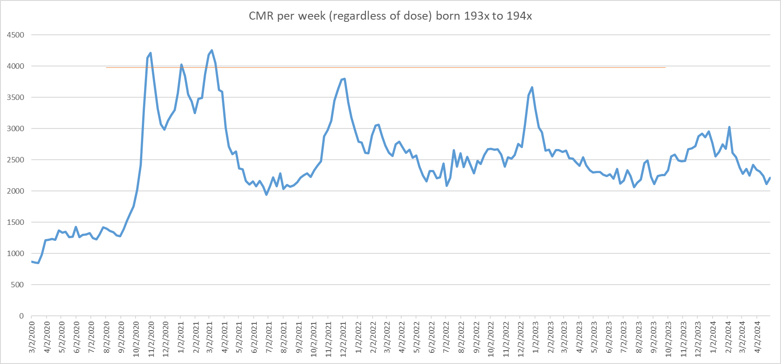

The invalidity of “eyeballing peaks” was already addressed here. The appropriate reference is [cumulative Covid deaths](https://www.worldometers.info/coronavirus/country/czech-republic/), which show that over 70% of deaths occurred before vaccinations were prevalent ([Q2-2021](https://ourworldindata.org/explorers/covid?zoomToSelection=true&facet=none&uniformYAxis=0&country=~CZE&pickerSort=asc&pickerMetric=location&hideControls=false&Metric=Vaccine+doses&Interval=7-day+rolling+average&Relative+to+population=true)).

## Other Countries

Owing to word-count constraints, SK’s assertions concerning other countries are addressed here only in concise form; full expansions and supporting evidence can be provided during the forthcoming discussions with the judges.

### Japan

“Japan—the most highly dosed country in the world—showed a large, sustained, multi-year national excess mortality rise beginning post-rollout. While ecological, this population signal is **consistent** with the cohort-level findings above”.

# 

This is a common mistake in interpreting Japan’s Covid deaths. Japan changed its reporting of Covid deaths on 8-May-2023, explaining the abrupt stop in this graph. In practice, all ED in Japan is attributed to Covid, and overall, the highly-boosted Japan had far lower ED than the less-vaccinated US (the subject of the main debate).

### Australia

Here’s Australia. Same thing. Even after COVID flattened, excess death KEPT RISING.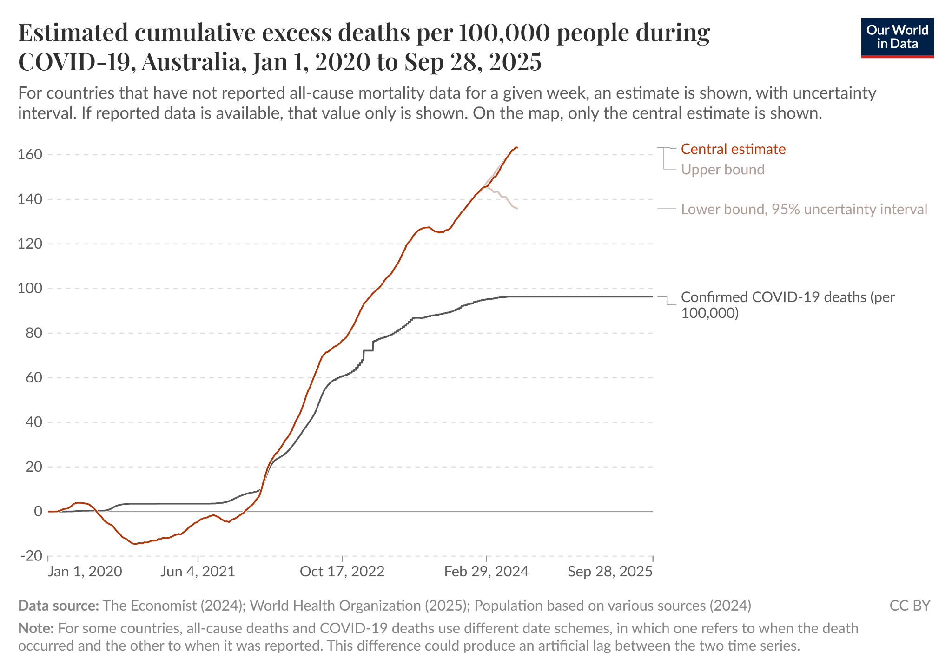

Calculating EDs is sensitive to baseline choices. This plot seems to be based on Crude Mortality Rate (it’s near-identical to [Australia’s CMR chart on mortality.watch](https://www.mortality.watch/explorer/?c=AUS&t=cmr&ct=weekly&e=1&cs=line&df=2020%2520W01&bf=2015%2520W01&ce=1&st=0&pi=0&sl=0&p=0)), which is sensitive to changes in population composition. Below is the ED based on ASMR, which is more robust, and trends down.

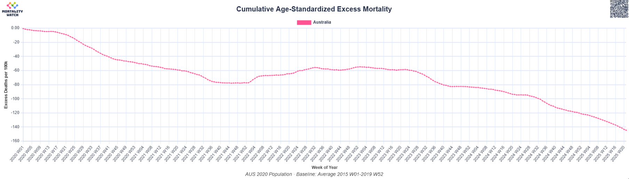

Furthermore, As quoted above (Japan), we again note KCOR claims VIDs are “long gone” after one year, producing close to a 30% increase in ACM during that time. Meanwhile Australia, one of 5 countries that maintained Zero-Covid for roughly a year, [didn’t have any ED for the first 10 months post-vaccination](https://www.frontiersin.org/journals/public-health/articles/10.3389/fpubh.2023.1085451/full) (until Omicron and Australia’s first Covid wave) - just like the other 4 Zero-Covid countries.

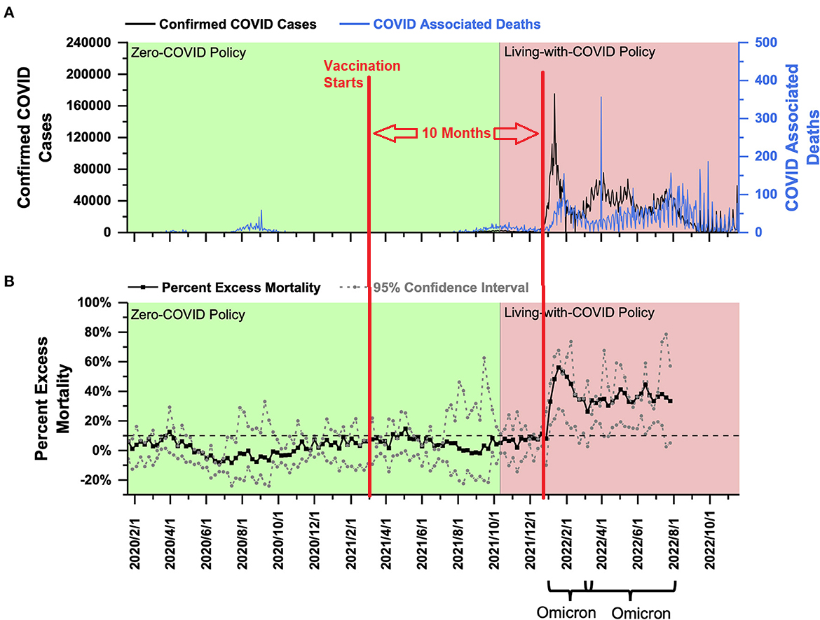

Figure 13

### Qatar

“[Qatar study](https://elifesciences.org/articles/103690): They did t**he most extreme 1:1 matching ever done in a study**. The aHR for non-COVID death was >1 after 6 months, despite a HUGE (and clearly false) HVE benefit (we know the vaccines don’t reduce NCACM).”  
  
“In the first 6 months of follow-up in the two-dose analysis, the aHR was **0.35** (95% CI: 0.27–0.46); however, the combined analysis of all subsequent periods showed an aHR of **1.52** (95% CI: 1.19–1.94). In the first 6 months of follow-up in the three-dose analysis, the aHR was **0.31** (95% CI: 0.20–0.50); however, the combined analysis of all subsequent periods showed an aHR of **1.37** (95% CI: 1.02–1.85).”

Firstly, SK quoted the paper while removing the finding of a total net benefit (below). If the paper’s methodology is valid, it refutes KCOR predictions. If it is not, one cannot cherry-pick KCOR corroborations from it.

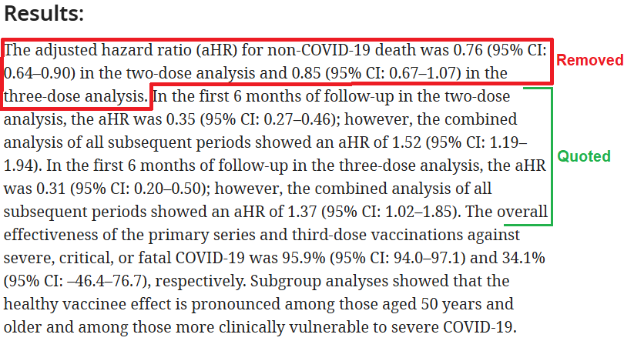

Beyond this, countries exhibit distinct HVE profiles that evolve over time and may even reverse direction. Therefore, even if SK’s interpretation of the Qatar data were correct, it would not constitute sufficient evidence for Czechia.

Finally, although the Qatar study was unable to definitively identify the drivers of the observed mortality patterns, it attributed the short-term selection bias to HVE and the long-term bias to reverse HVE (“indication effect”), thereby illustrating that HVE can vary over time and even invert. Given that the median age of the cohort is 34 years, the indication effect is likely to be substantial.

### Hungary

“[Hungary study](https://pmc.ncbi.nlm.nih.gov/articles/PMC9319484/): Fig 1 and 2 are the smoking guns. These are KM plots. They reveal 3 huge red flags:  
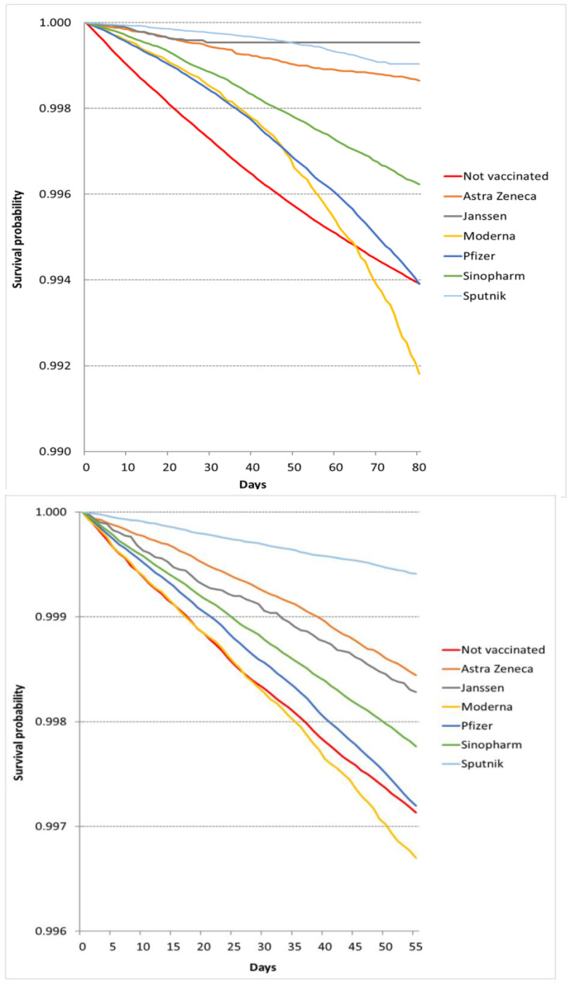

1. Moderna always had the worst survival despite having the healthiest cohort.
2. Moderna curve pathologically deviates downward
3. During both periods the Pfizer and unvaccinated curve match at the end. Having one match can just be a coincidence. Having them match in both periods means the vaccine provided no protection during COVID (and Moderna was even worse).”

The charts above are irrelevant for assessing vaccine deaths, as the groups are not age-matched. The different slopes are thus simply the mortality rate applicable to their age distribution and health.

Supplementary Table S1 of the quoted study specifically shows unvaccinated are around 12 years younger than mRNA vaccinated, and have far fewer risk factors.

The downward curve of Moderna and Pfizer vs the upward curve of unvaccinated is likely HVE - with very frail not being vaccinated, and dying early.

### SOA

“The US had over a 100% increase in mortality among our healthiest WORKING age group when corporate vaccine mandates rolled out. It was not COVID. Nobody has been able to explain what caused this and it wasn’t COVID: See Red values. From [SOA report”.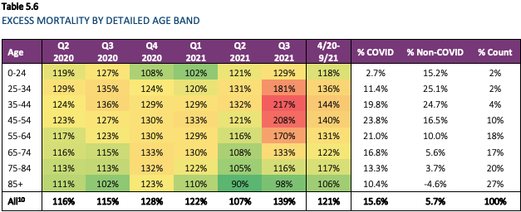](https://www.soa.org/48ff80/globalassets/assets/files/resources/research-report/2022/group-life-covid-19-mortality.pdf)

This local spike in young deaths is due to the delta wave, and is anyway implausible for VID from vaccines administered 6 months earlier with no increase prior. The sustained ED is due to overdoses, shooting, and accidents, which increased in 2020 pre-vaccines.

This is actually evidence of vaccine effectiveness, as the reason young ages increased more (relatively, not in absolute numbers) is due to their lower vaccination rate. Plotting [CDC Covid deaths](https://www.cdc.gov/nchs/nvss/vsrr/covid19/excess_deaths.htm) by age each year, shows that while in 2020 (pre-vaccines) deaths increased with age, in 2021 (post-vaccines) the oldest were more protected. This reversed back in 2022 as the unvaccinated gained natural immunity.

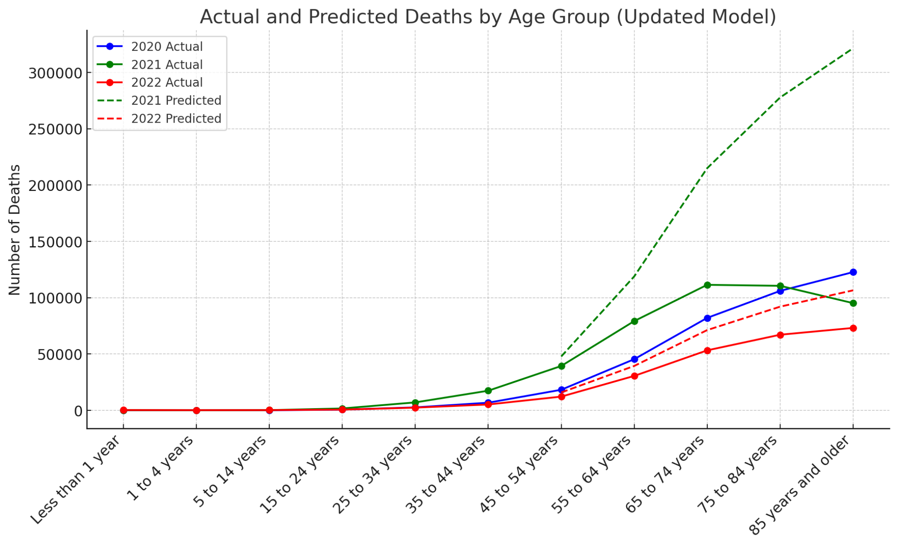

Figure 14

In Czechia there is no strong preference to the older age groups, and indeed their delta wave affected all ages similarly.

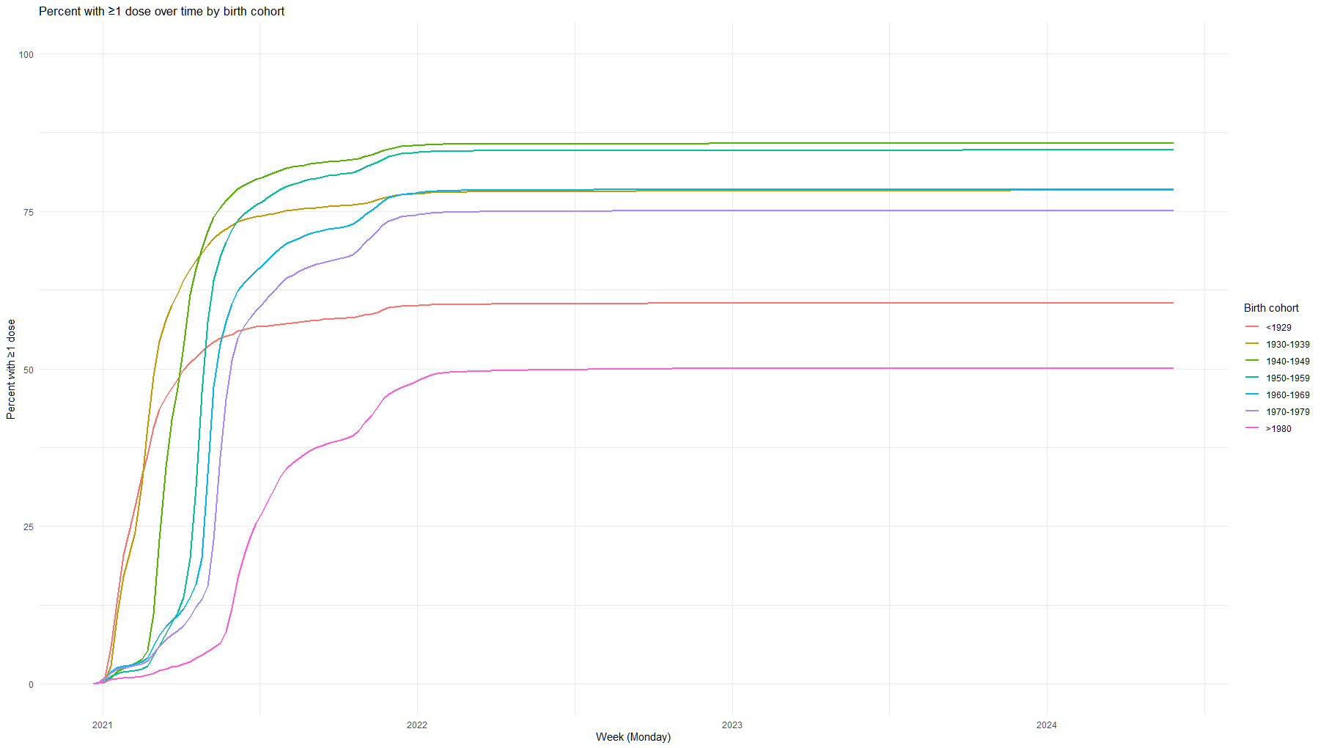

Figure 15